Mirshahi, Nazanin, mirshahin@mymail.vcu.edu

Your results HW2
Dear folk
I send to you results i got when running your HW2.
If these results same like yours then you don't need notice me, if not please contact me by email
Sincerely
Dat Nguyen

Beata
Implementation of CLIP4 Algorithm - Beata Strack -
- results will be both displayed in a window and saved in output file
Noise tereshold:2
Dataset name: Travel Agency Data
---------------------------------------------------------------------------------------
Rules for positive case: Decision = Buy
---------------------------------------------------------------------------------------
IF Age != Very young AND Age != Middle AND Age != Young THEN Decision = Buy
IF Type of Call != Intern AND Lang Fluency != Not fluent AND Lang Fluency != Foreign THEN Decision = Buy
---------------------------------------------------------------------------------------
Rules for positive case: Decision = Not buy
---------------------------------------------------------------------------------------
IF Type of Call != Local AND Type of Call != Long AND Lang Fluency != Not fluent AND Lang Fluency != Accent THEN Decision = Not buy
IF Type of Call != Long AND Lang Fluency != Fluent AND Lang Fluency != Accent THEN Decision = Not buy
-----------Output saved in output.txt file-----------
mplementation of CLIP4 Algorithm - Beata Strack -
- results will be both displayed in a window and saved in output file
Noise tereshold:2
Dataset name: relation weather symbolic
---------------------------------------------------------------------------------------
Rules for positive case: play = no
---------------------------------------------------------------------------------------
IF outlook != overcast AND outlook != rainy AND humidity != normal THEN play = no
IF outlook != overcast AND outlook != sunny AND windy != FALSE THEN play = no
---------------------------------------------------------------------------------------
Rules for positive case: play = yes
---------------------------------------------------------------------------------------
IF outlook != sunny AND outlook != rainy THEN play = yes
IF outlook != sunny AND windy != TRUE THEN play = yes
IF outlook != rainy AND humidity != high THEN play = yes
-----------Output saved in output.txt file-----------
Implementation of CLIP4 Algorithm - Beata Strack -
- results will be both displayed in a window and saved in output file
Noise tereshold:2
Dataset name: Famous database from Fisher 1936
---------------------------------------------------------------------------------------
Rules for positive case: classname = Iris-setosa
---------------------------------------------------------------------------------------
IF petallength != (2.45-4.75] AND petallength != (4.75-6.9] THEN classname = Iris-setosa
---------------------------------------------------------------------------------------
Rules for positive case: classname = Iris-versicolor
---------------------------------------------------------------------------------------
IF sepalwidth != [2-2.95] AND petallength != [1-2.45] AND petallength != (4.75-6.9] THEN classname = Iris-versicolor
IF sepallength != [4.3-5.55] AND sepallength != (6.25-7.9] AND petallength != [1-2.45] AND petallength != (4.75-6.9] THEN classname = Iris-versicolor
---------------------------------------------------------------------------------------
Rules for positive case: classname = Iris-virginica
---------------------------------------------------------------------------------------
IF sepalwidth != (3.05-4.4] AND sepalwidth != [2-2.95] AND petalwidth != [0.1-0.8] AND petalwidth != (0.8-1.75] THEN classname = Iris-virginica
IF sepallength != [4.3-5.55] AND sepallength != (5.55-6.25] AND petalwidth != [0.1-0.8] AND petalwidth != (0.8-1.75] THEN classname = Iris-virginica
-----------Output saved in output.txt file-----------

Erik
IF outlook <> overcast AND outlook <> sunny AND windy <> false THEN play = no
IF outlook <> overcast AND outlook <> rainy AND humidity <> normal THEN play = no
IF outlook <> sunny AND outlook <> rainy THEN play = yes
IF outlook <> sunny AND windy <> true THEN play = yes

IF Age <> very young AND Age <> middle AND Age <> young THEN Decision = buy
IF Type of Call <> intern AND Lang Fluency <> not fluent AND Lang Fluency <> foreign THEN Decision = buy
IF Type of Call <> local AND Type of Call <> long AND Lang Fluency <> not fluent AND Lang Fluency <> accent THEN Decision = not buy
IF Type of Call <> long AND Lang Fluency <> fluent AND Lang Fluency <> accent THEN Decision = not buy
IF petallength <> (2.45-4.75] AND petallength <> (4.75-6.9] THEN classname = iris-setosa
IF sepalwidth <> (2.95-3.05] AND sepalwidth <> [2-2.95] AND petallength <> (4.75-6.9] THEN classname = iris-versicolor
IF sepalwidth <> [2-2.95] AND petallength <> [1-2.45] AND petallength <> (4.75-6.9] THEN classname = iris-versicolor
IF sepalwidth <> (3.05-4.4] AND petalwidth <> [0.1-0.8] AND petalwidth <> (0.8-1.75] THEN classname = iris-virginica

Robert
if outlook != overcast and outlook != rainy and humidity != normal then no
if outlook != overcast and outlook != sunny and windy != FALSE then no
if outlook != rainy and outlook != sunny then yes
if outlook != sunny and windy != TRUE then yes
if outlook != rainy and humidity != high then yes
if Age != Middle and Age != Very young and Age != Young then Buy
if Type of Call != Intern and Lang Fluency != Foreign and Lang Fluency != Not fluent then Buy
if Type of Call != Local and Type of Call != Long and Lang Fluency != Accent and Lang Fluency != Not fluent then Not buy
if Type of Call != Long and Lang Fluency != Accent and Lang Fluency != Fluent then Not buy
if petallength != (2.45-4.75] and petallength != (4.75-6.9] then Iris-setosa
if sepallength != [4.3-5.55] and petallength != (4.75-6.9] and petallength != [1-2.45] then Iris-versicolor
if sepalwidth != [2-2.95] and petallength != (4.75-6.9] and petallength != [1-2.45] then Iris-versicolor
if sepalwidth != (3.05-4.4] and petalwidth != (0.8-1.75] and petalwidth != [0.1-0.8] then Iris-virginica
if sepallength != (5.55-6.25] and sepallength != [4.3-5.55] and petalwidth != (0.8-1.75] and petalwidth != [0.1-0.8] then Iris-virginica
Sam

Final Rule List
Class 0 - play = no
Rule 0
If outlook<>overcast AND outlook<>rainy AND humidity<>normal THEN play = no
Rule 1
If outlook<>overcast AND outlook<>sunny AND windy<>FALSE THEN play = no
Class 1 - play = yes
Rule 0
If outlook<>sunny AND windy<>TRUE THEN play = yes
Rule 1
If outlook<>rainy AND humidity<>high THEN play = yes
Rule 2
If outlook<>sunny AND outlook<>rainy THEN play = yes
************************************************
Final Rule List

Class 0 - Decision = Buy

Rule 0
If Age<>Veryyoung AND Age<>Middle AND Age<>Young THEN Decision = Buy

Rule 1
If TypeofCall<>Intern AND LangFluency<>Notfluent AND LangFluency<>Foreign
THEN Decision = Buy

Class 1 - Decision = Notbuy

Rule 0
If TypeofCall<>Long AND LangFluency<>Fluent AND LangFluency<>Accent THEN D
ecision = Notbuy

Rule 1
If TypeofCall<>Local AND TypeofCall<>Long AND LangFluency<>Notfluent AND L
angFluency<>Accent THEN Decision = Notbuy
************************************************
Final Rule List
Class 0 - classname = Iris-setosa
Rule 0
If petallength<>(2.45-4.75] AND petallength<>(4.75-6.9] THEN classname = I
ris-setosa

Class 1 - classname = Iris-versicolor

Rule 0
If petalwidth<>[0.1-0.8] AND petalwidth<>(1.75-2.5] THEN classname = Iris-
versicolor

Rule 1
If sepallength<>[4.3-5.55] AND sepallength<>(6.25-7.9] AND sepalwidth<>(2.
95-3.05] AND sepalwidth<>[2-2.95] THEN classname = Iris-versicolor

Class 2 - classname = Iris-virginica

Rule 0
If sepallength<>[4.3-5.55] AND sepallength<>(5.55-6.25] AND petalwidth<>[0
.1-0.8] AND petalwidth<>(0.8-1.75] THEN classname = Iris-virginica

Rule 1
If sepalwidth<>(3.05-4.4] AND petalwidth<>[0.1-0.8] AND petalwidth<>(0.8-1
.75] THEN classname = Iris-virginica

Venkat Chennu
With test1w.txt
The result is
if coloumn 1!=1 coloumn 1!=3 coloumn 1!=2 then true(buy/play)
With test2w.txt
The result is
if coloumn 0!=3 coloumn 0!=2 coloumn 0!=3 coloumn 0!=1 coloumn 0!=2 coloumn 0!=1 coloumn 0!=3 then true(buy/play)

Liu
relationweathersymbolic
the positive class is no
rule 1:
if outlook <> overcast and outlook <> rainy and humidity <> normal then play = no
rule 2:
if outlook <> overcast and outlook <> sunny and windy <> FALSE then play = no
the positive class is yes
rule 1:
if outlook <> rainy and outlook <> sunny then play = yes
rule 2:
if outlook <> sunny and windy <> TRUE then play = yes
rule 3:
if outlook <> rainy and humidity <> high then play = yes
TravelAgencyData
the positive class is Buy
rule 1:
if Age <> Middle and Age <> Veryyoung and Age <> Young then Decision = Buy
rule 2:
if TypeofCall <> Intern and LangFluency <> Foreign and LangFluency <> Notfluent then Decision = Buy
the positive class is Notbuy
rule 1:
if TypeofCall <> Local and TypeofCall <> Long and LangFluency <> Accent and LangFluency <> Notfluent then Decision = Notbuy
rule 2:
if TypeofCall <> Long and LangFluency <> Accent and LangFluency <> Fluent then Decision = Notbuy
FamousdatabasefromFisher1936
the positive class is Iris-setosa
rule 1:
if petallength <> (2.45-4.75] and petallength <> (4.75-6.9] then classname = Iris-setosa
the positive class is Iris-versicolor
rule 1:
if sepallength <> (6.25-7.9] and sepallength <> [4.3-5.55] and sepalwidth <> (2.95-3.05] and sepalwidth <> [2-2.95] and petallength <> [1-2.45] then classname = Iris-versicolor
rule 2:
if petalwidth <> (1.75-2.5] and petalwidth <> [0.1-0.8] then classname = Iris-versicolor
the positive class is Iris-virginica
rule 1:
if sepallength <> (5.55-6.25] and sepallength <> [4.3-5.55] and petalwidth <> (0.8-1.75] and petalwidth <> [0.1-0.8] then classname = Iris-virginica
rule 2:
if sepalwidth <> (3.05-4.4] and petalwidth <> (0.8-1.75] and petalwidth <> [0.1-0.8] then classname = Iris-virginica

NING
IF( outlook # overcast) AND ( outlook # rainy) AND ( humidity # normal) THEN play = no
IF( outlook # overcast) AND ( outlook # sunny) AND ( windy # FALSE) THEN play = no
IF( outlook # rainy) AND ( humidity # high) THEN play = yes
IF( outlook # rainy) AND ( outlook # sunny) THEN play = yes
IF( outlook # sunny) AND ( windy # TRUE) THEN play = yes

IF( Age # Middle) AND ( Age # Veryyoung) AND ( Age # Young) THEN Decision = Buy
IF( TypeofCall # Intern) AND ( LangFluency # Foreign) AND ( LangFluency # Notfluent) THEN Decision = Buy
IF( TypeofCall # Intern) AND ( TypeofCall # Long) AND ( LangFluency # Accent) AND ( LangFluency # Fluent) THEN Decision = Notbuy
IF( TypeofCall # Local) AND ( TypeofCall # Long) AND ( LangFluency # Accent) AND ( LangFluency # Notfluent) THEN Decision = Notbuy
IF( TypeofCall # Long) AND ( LangFluency # Accent) AND ( LangFluency # Fluent) THEN Decision = Notbuy
IF( petallength # (2.45-4.75]) AND ( petallength # (4.75-6.9]) THEN classname = Iris-setosa
IF( petalwidth # (1.75-2.5]) AND ( petalwidth # [0.1-0.8]) THEN classname = Iris-versicolor
IF( sepallength # (5.55-6.25]) AND ( sepallength # [4.3-5.55]) AND ( petalwidth # (0.8-1.75]) AND ( petalwidth # [0.1-0.8]) THEN classname = Iris-virginica
IF( sepallength # (6.25-7.9]) AND ( sepallength # [4.3-5.55]) AND ( sepalwidth # (2.95-3.05]) AND ( sepalwidth # [2-2.95]) AND ( petallength # [1-2.45]) THEN classname = Iris-versicolor
IF( sepalwidth # (3.05-4.4]) AND ( petalwidth # (0.8-1.75]) AND ( petalwidth # [0.1-0.8]) THEN classname = Iris-virginica

Qi
the data file basic information as below:
relation weather symbolic
outlook,temperature,humidity,windy,play
S,S,S,S,S
-----*** Rules for "no" as below: ***-----
IF "outlook" # overcast "temperature" # mild "windy" # FALSE THEN "no"
IF "outlook" # overcast "outlook" # rainy "humidity" # normal THEN "no"
IF "outlook" # overcast "outlook" # sunny "windy" # FALSE THEN "no"
ELSE "yes"
Enter your data file name: Travel.txt
Your data file name is : Travel.txt
initializing the CLIP4 algrithm...
the data file basic information as below:
Travel Agency Data
Type of Call, Lang Fluency, Ticket Type,Age, Decision
S,S,S,S,S
-----*** Rules for "Buy" as below: ***-----
IF "Age" # Middle "Age" # Very young "Age" # Young THEN "Buy"
IF "Type of Call" # Intern "Lang Fluency" # Foreign "Lang Fluency" # Not fluent THEN "Buy"
ELSE "Not buy"

Enter your data file name: iris.txt
Your data file name is : iris.txt
initializing the CLIP4 algrithm...

the data file basic information as below:
Famous database from Fisher 1936
sepallength,sepalwidth,petallength,petalwidth,classname
S,S,S,S,S

-----*** Rules for "Iris-setosa" as below: ***-----
IF "petallength" # (2.45-4.75] "petallength" # (4.75-6.9] THEN "Iris-setosa"
ELSE "Iris-versicolor" OR "Iris-virginica" (the details as below:)
-----*** Rules for "Iris-versicolor" as below: ***-----
IF "sepalwidth" # [2-2.95] "petallength" # (4.75-6.9] THEN "Iris-versicolor"
IF "sepallength" # [4.3-5.55] "petallength" # (4.75-6.9] THEN "Iris-versicolor"
IF "sepalwidth" # (2.95-3.05] "sepalwidth" # [2-2.95] "petalwidth" # ( 1.75-2.5]
THEN "Iris-versicolor"
ELSE "Iris-virginica"
Enter your data file name: iris2.txt
Your data file name is : iris2.txt
initializing the CLIP4 algrithm...

the data file basic information as below:
Famous database from Fisher 1936
sepallength,sepalwidth,petallength,petalwidth,classname
S,S,S,S,S

-----*** Rules for "Iris-versicolor" as below: ***-----
IF "sepalwidth" # [2-2.95] "petallength" # (4.75-6.9] "petallength" # [1-2.45] THEN "Iris-versicolor"
IF "sepallength" # [4.3-5.55] "petallength" # (4.75-6.9] "petallength" # [1-2.45] THEN "Iris-versicolor"
IF "sepalwidth" # (2.95-3.05] "sepalwidth" # [2-2.95] "petalwidth" # (1.75-2.5] "petalwidth" # [0.1-0.8]
THEN "Iris-versicolor"
ELSE "Iris-virginica" OR "Iris-setosa" (the details as below:)
-----*** Rules for "Iris-virginica" as below: ***-----
IF "petallength" # [1-2.45] THEN "Iris-virginica"
ELSE "Iris-setosa"
Enter your data file name: iris3.txt
Your data file name is : iris3.txt
initializing the CLIP4 algrithm...
the data file basic information as below:
Famous database from Fisher 1936
sepallength,sepalwidth,petallength,petalwidth,classname
S,S,S,S,S

-----*** Rules for "Iris-virginica" as below: ***-----
IF "sepalwidth" # (3.05-4.4] "petalwidth" # (0.8-1.75] "petalwidth" # [0.1-0.8] THEN "Iris-virginica"
IF "sepallength" # (5.55-6.25] "sepallength" # [4.3-5.55] "petalwidth" # (0.8-1.75] "petalwidth" # [0.1-0.8] THEN "Iris-virginica"
ELSE "Iris-setosa" OR "Iris-versicolor" (the details as below:)

-----*** Rules for "Iris-setosa" as below: ***-----
IF "petallength" # (2.45-4.75] "petallength" # (4.75-6.9]THEN "Iris-setosa"
ELSE "Iris-versicolor"

SMITH
IF (outlook <> sunny) AND (windy <> TRUE) THEN play = yes
IF (outlook <> rainy) AND (humidity <> high) THEN play = yes
IF (outlook <> sunny) AND (outlook <> rainy) THEN play = yes
3 Rules
Correct=14 Incorrect=0
IF (outlook <> overcast) AND (outlook <> rainy) AND (humidity <> normal) THEN play = no
IF (outlook <> overcast) AND (outlook <> sunny) AND (windy <> FALSE) THEN play = no
2 Rules
Correct=14 Incorrect=0
IF (Age <> Very young) AND (Age <> Middle) AND (Age <> Young) THEN Decision = Buy
IF (Type of Call <> Intern) AND (Lang Fluency <> Not fluent) AND (Lang Fluency <> Foreign) THEN Decision = Buy
2 Rules
Correct=9 Incorrect=0
IF (Type of Call <> Long) AND (Lang Fluency <> Fluent) AND (Lang Fluency <> Accent) THEN Decision = Not buy
IF (Type of Call <> Local) AND (Type of Call <> Long) AND (Lang Fluency <> Not fluent) AND (Lang Fluency <> Accent) THEN Decision = Not buy
2 Rules
Correct=9 Incorrect=0
IF (petallength <> (2.45-4.75]) AND (petallength <> (4.75-6.9]) THEN classname = Iris-setosa
1 Rules
Correct=27 Incorrect=0
IF (sepallength <> [4.3-5.55]) AND (petallength <> [1-2.45]) AND (petallength <> (4.75-6.9]) THEN classname = Iris-versicolor
IF (sepalwidth <> (2.95-3.05]) AND (sepalwidth <> [2-2.95]) AND (petalwidth <> [0.1-0.8]) AND (petalwidth <> (1.75-2.5]) THEN classname = Iris-versicolor
IF (sepalwidth <> (3.05-4.4]) AND (sepalwidth <> [2-2.95]) AND (petallength <> [1-2.45]) AND (petallength <> (4.75-6.9]) THEN classname = Iris-versicolor
3 Rules
Correct=22 Incorrect=5
IF (sepalwidth <> (3.05-4.4]) AND (petalwidth <> [0.1-0.8]) AND (petalwidth <> (0.8-1.75]) THEN classname = Iris-virginica
IF (sepallength <> [4.3-5.55]) AND (sepallength <> (5.55-6.25]) AND (petalwidth <> [0.1-0.8]) AND (petalwidth <> (0.8-1.75]) THEN classname = Iris-virginica
2 Rules
Correct=22 Incorrect=5

SALMAN
-----------------Rules------------------
IF outlook#overcast AND outlook#rainy THEN play no;
IF outlook#overcast THEN play no;
IF outlook#sunny AND outlook#rainy THEN play yes;
-----------------Rules------------------
-----------------Rules------------------
IF Lang_Fluency#Not fluent AND Lang_Fluency#Foreign THEN Decision Buy; IF Lang_Fluency#Not fluent AND Lang_Fluency#Foreign THEN Decision Buy;
IF Lang_Fluency#Fluent AND Lang_Fluency#Not fluent AND Lang_Fluency#Accent THEN Decision Not buy;
-----------------Rules------------------
IF Lang_Fluency#Fluent AND Lang_Fluency#Not fluent AND Lang_Fluency#Accent THEN Decision Not buy; IF Age#Very young AND Age#old AND Age#Very old THEN Decision Not buy;
----------end----------
>>
----------------Rules------------------
IF petallength#(0.8-1.75] AND petallength#(1.75-2.5] THEN classname Iris-setosa; IF petallength#(0.8-1.75] AND petallength#(1.75-2.5] THEN classname Iris-setosa;
IF petallength#[0.1-0.8] THEN classname Iris-setosa;
-----------------Rules------------------
IF petallength#[0.1-0.8] AND petallength#(1.75-2.5] THEN classname Iris-versicolor;
-----------------Rules------------------
IF petallength#[0.1-0.8] AND petallength#(1.75-2.5] THEN classname Iris-versicolor; IF petalwidth#Iris-setosa AND petalwidth#Iris-virginica THEN classname Iris-versicolor;
IF petallength#(0.8-1.75] AND petallength#(1.75-2.5] THEN classname Iris-versicolor;
-----------------Rules------------------
IF petalwidth#Iris-setosa AND petalwidth#Iris-versicolor THEN classname Iris-virginica;
-----------------Rules------------------
IF petalwidth#Iris-setosa AND petalwidth#Iris-versicolor THEN classname Iris-virginica; IF petalwidth#Iris-setosa AND petalwidth#Iris-versicolor THEN classname Iris-virginica;
IF petallength#(1.75-2.5] THEN classname Iris-virginica;
-----------------Rules------------------
IF petallength#(1.75-2.5] THEN classname Iris-virginica; IF petallength#(1.75-2.5] THEN classname Iris-virginica;
----------end----------
>>

Laurent

>> Weather
If
'Outlook'

'Sunny'

and
'Rainy'

then Play = Yes
If
'Outlook'

'Rainy'

and
'Humdity'

'High'

then Play = Yes
If
'Outlook'

'Sunny'

and
'Windy'

'True'

then Play = Yes
If
'Outlook'

'Sunny'

and
'Over'

then Play = No
>>
>> Travel
If
'Age'

'Very Young'

and
'Young'

and
'Middle'

and
'Old'

then Decision = Buy
If
'Type of Call'

'International'

and
'Lang. fluency'

'Not Fluent'

and
'Foreign'

then Decision = Buy
If
'Type of Call'

'Long Distance'

and
'International'

and
'Lang. fluency'

'Fluent'

and
'Accent'

then Decision = Not Buy
>>
>> Iris
If
'sepallength'

'[4.3-5.55]'

and
'petallength'

'[1-2.45]'

and
'(4.75-6.9]'

Classname = Iris-Versicolor
If
and
'sepalwidth'

'[2-2.95]'

and
'petallength'

'[1-2.45]'

and
'(4.75-6.9]'

Classname = Iris-Versicolor
If
and
'sepalwidth'

'[2-2.95]'

and
'(2.95-3.05]'

and
'petalwidth'

'[0.1-0.8]'

and
'(0.8-1.75]'

Classname = Iris-Verginica
If
'sepallength'

'[4.3-5.55]'

and
'(5.55-6.25]'

and
'petalwidth'

'[0.1-0.8]'

and
'(0.8-1.75]'

Classname = Iris-Verginica
>>

JIE
Please put the path and name of the data file in TXT format:
Weather.txt
RULE =
IF(outlook # overcast) AND(outlook # rainy) AND(humidity # normal)THEN play = no
RULE =
IF(outlook # sunny) AND(outlook # overcast) AND(windy # FALSE)THEN play = no
RULE =
IF(outlook # rainy) AND(humidity # high)THEN play = yes
RULE =
IF(outlook # sunny) AND(windy # TRUE)THEN play = yes
RULE =
IF(outlook # sunny) AND(outlook # rainy)THEN play = yes

Do you want to continue for other datasets? Y/N [Y]:
Do you want to continue for other datasets? Y/N [Y]: y
Please put the path and name of the data file in TXT format:
Travel.txt

RULE =
IF(Type of Call # Intern) AND(Lang Fluency # Not fluent) AND(Lang Fluency # Foreign)THEN Decision = Buy
RULE =
IF(Age # Very young) AND(Age # Young) AND(Age # Middle)THEN Decision = Buy
RULE =
IF(Type of Call # Long) AND(Lang Fluency # Fluent) AND(Lang Fluency # Accent)THEN Decision = Not Buy
RULE =
IF(Type of Call # Local) AND(Type of Call # Long) AND(Lang Fluency # Accent) AND(Lang Fluency # Not fluent)THEN Decision = Not Buy

Do you want to continue for other datasets? Y/N [Y]:
Please put the path and name of the data file in TXT format:
Iris.txt
RULE =
IF(petallength # (2.45-4.75]) AND(petallength # (4.75-6.9])THEN classname = Iris-setosa
RULE =
IF(sepalwidth # [2-2.95]) AND(petallength # [1-2.45]) AND(petallength # (4.75-6.9])THEN classname = Iris-versicolor
RULE =
IF(sepallength # [4.3-5.55]) AND(petallength # [1-2.45]) AND(petallength # (4.75-6.9])THEN classname = Iris-versicolor
RULE =
IF(sepalwidth # [2-2.95]) AND(sepalwidth # (2.95-3.05]) AND(petalwidth # [0.1-0.8]) AND(petalwidth # (1.75-2.5])THEN classname = Iris-versicolor
RULE =
IF(sepalwidth # (3.05-4.4]) AND(petalwidth # [0.1-0.8]) AND(petalwidth # (0.8-1.75])THEN classname = Iris-virginica
RULE =
IF(sepallength # [4.3-5.55]) AND(sepallength # (5.55-6.25]) AND(petalwidth # [0.1-0.8]) AND(petalwidth # (0.8-1.75])THEN classname = Iris-virginica

Do you want to continue for other datasets? Y/N [Y]:

Lou
Dataset: Travel.txt
CLIP4 produce the following rules :
Rule1=IF Age#Middle AND Age#Very young AND Age#Young THEN Decision=Buy
Rule2=IF Type of Call#Intern AND Lang Fluency#Foreign AND Lang Fluency#Not fluent THEN Decision=Buy
>>
Dataset: Travel.txt
CLIP4 produce the following rules :
Rule1=IF Type of Call#Long AND Lang Fluency#Accent AND Lang Fluency#Fluent THEN Decision=Not buy
Rule2=IF Type of Call#Local AND Type of Call#Long AND Lang Fluency#Accent AND Lang Fluency#Not fluent THEN Decision=Not buy
>>

Dataset: Weather.txt
CLIP4 produce the following rules :
Rule1=IF outlook#sunny AND windy#TRUE THEN play=yes
Rule2=IF outlook#rainy AND humidity#high THEN play=yes
Rule3=IF outlook#rainy AND outlook#sunny THEN play=yes

Dataset: Weather.txt
CLIP4 produce the following rules :
Rule1=IF outlook#overcast AND outlook#rainy AND humidity#normal THEN play=no
Rule2=IF outlook#overcast AND outlook#sunny AND windy#FALSE THEN play=no

Dataset: Iris.txt
CLIP4 produce the following rules :
Rule1=IF petallength#(2.45-4.75] AND petallength#(4.75-6.9] THEN classname=Iris-setosa
Rule2=IF sepallength#[4.3-5.55] AND petallength#(4.75-6.9] AND petallength#[1-2.45] THEN classname=Iris-versicolor
Rule3=IF sepalwidth#[2-2.95] AND petallength#(4.75-6.9] AND petallength#[1-2.45] THEN classname=Iris-versicolor
Rule4=IF sepalwidth#(3.05-4.4] AND petalwidth#(0.8-1.75] AND petalwidth#[0.1-0.8] THEN classname=Iris-virginica
Rule5=IF sepallength#(5.55-6.25] AND sepallength#[4.3-5.55] AND petalwidth#(0.8-1.75] AND petalwidth#[0.1-0.8] THEN classname=Iris-virginica
>>

Early
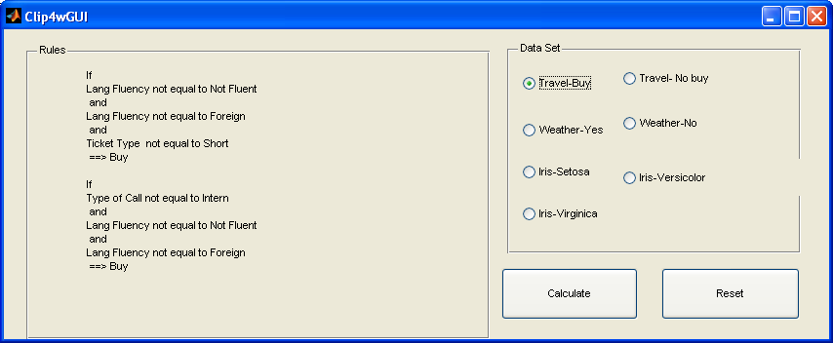
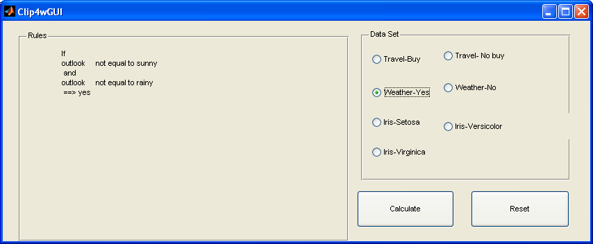

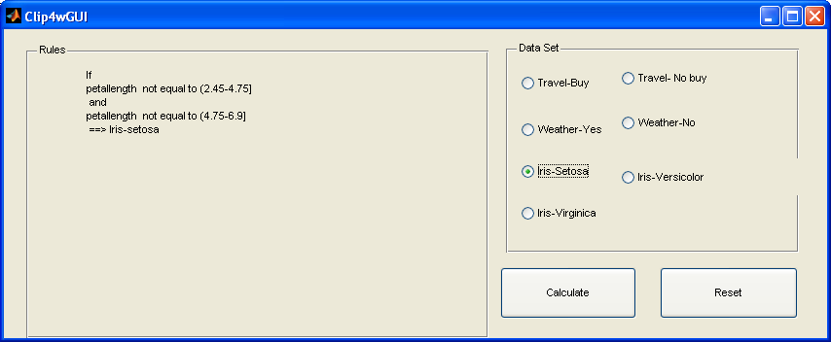
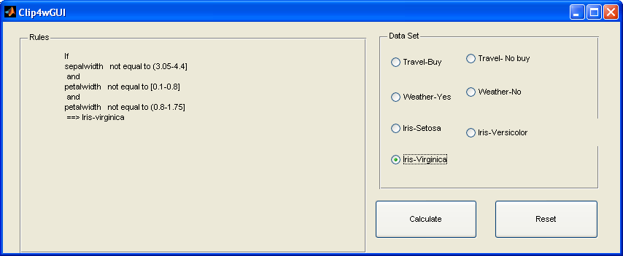
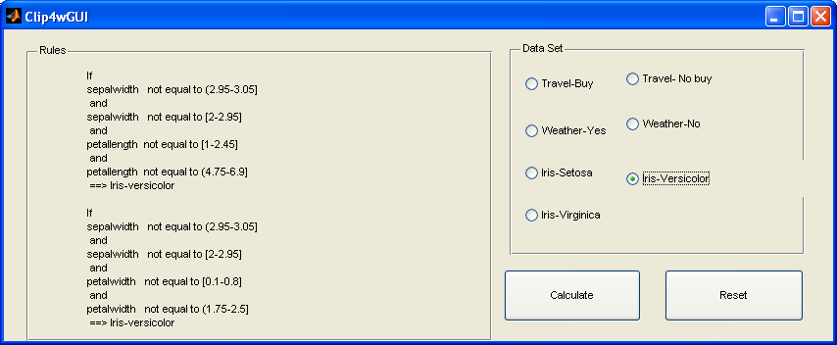
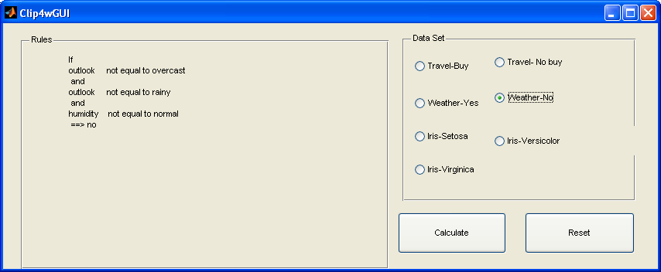
Some wrong below
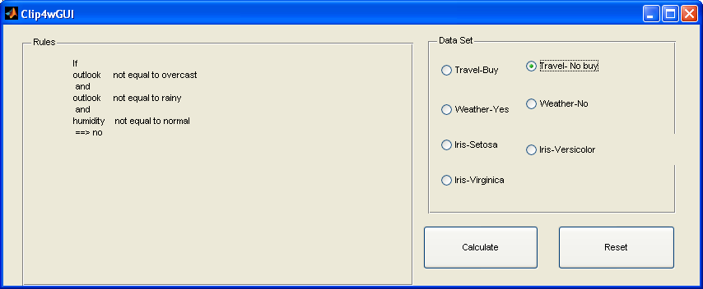

DongNing
This is result for data: Travel Agency Data

IF Age ~= Very young && Age ~= Middle && Age ~= Middle && Age ~= Young Then Class = Buy
IF Type of Call ~= Intern && Lang Fluency ~= Not fluent && Lang Fluency ~= Not fluent && Lang Fluency ~= Foreign Then Class = Buy
>>
This is result for data: Travel Agency Data

IF Type of Call ~= Long && Lang Fluency ~= Fluent && Lang Fluency ~= Accent Then Class = Not buy
IF Type of Call ~= Local && Type of Call ~= Long && Lang Fluency ~= Not fluent && Lang Fluency ~= Accent Then Class = Not buy
>>

This is result for data: relation weather symbolic

IF outlook ~= overcast && outlook ~= rainy && humidity ~= normal Then Play = No
IF outlook ~= sunny && outlook ~= overcast && windy ~= FALSE Then Play = No
>>
This is result for data: relation weather symbolic

IF outlook ~= sunny && windy ~= TRUE Then Play = Yes
IF outlook ~= rainy && humidity ~= high Then Play = Yes
>>
This is result for data: Famous database from Fisher 1936

IF petallength ~= (2.45-4.75] && petallength ~= (4.75-6.9] Then Class = iris-sentosa
>>
This is result for data: Famous database from Fisher 1936

IF sepallength ~= [4.3-5.55] && petallength ~= [1-2.45] && petallength ~= (4.75-6.9] Then Class = Iris-versicolor
IF sepalwidth ~= (2.95-3.05] && sepalwidth ~= [2-2.95] && petalwidth ~= [0.1-0.8] && petalwidth ~= (1.75-2.5] Then Class = Iris-versicolor
>>

This is result for data: Famous database from Fisher 1936

IF sepallength ~= [4.3-5.55] && sepallength ~= (5.55-6.25] && petalwidth ~= [0.1-0.8] && petalwidth ~= (0.8-1.75] Then Class = Iris-virginica
IF sepalwidth ~= (3.05-4.4] && petalwidth ~= [0.1-0.8] && petalwidth ~= (0.8-1.75] Then Class = Iris-virginica
>>

Sarah
outlook!=overcast ANDoutlook!=sunny ANDwindy!=FALSE THENno

outlook!=overcast ANDoutlook!=rainy ANDhumidity!=normal THENno

outlook!=sunny ANDwindy!=TRUE THENyes

outlook!=rainy ANDhumidity!=high THENyes

outlook!=sunny ANDoutlook!=rainy THENyes

Age!=Very young ANDAge!=Middle ANDAge!=Young THENBuy

Type of Call!=Intern ANDLang Fluency!=Not fluent ANDLang Fluency!=Foreign THENBuy

Type of Call!=Long ANDLang Fluency!=Fluent ANDLang Fluency!=Accent THENNot buy

Type of Call!=Local ANDType of Call!=Long ANDLang Fluency!=Not fluent ANDLang Fluency!=Accent THENNot buy

petallength!=(2.45-4.75] ANDpetallength!=(4.75-6.9] THENIris-setosa

sepallength!=[4.3-5.55] ANDpetallength!=[1-2.45] ANDpetallength!=(4.75-6.9] THENIris-versicolor

sepalwidth!=(2.95-3.05] ANDsepalwidth!=[2-2.95] ANDpetalwidth!=[0.1-0.8] ANDpetalwidth!=(1.75-2.5] THENIris-versicolor

sepalwidth!=(3.05-4.4] ANDsepalwidth!=[2-2.95] ANDpetallength!=[1-2.45] ANDpetallength!=(4.75-6.9] THENIris-versicolor

sepallength!=[4.3-5.55] ANDsepallength!=(5.55-6.25] ANDpetalwidth!=[0.1-0.8] ANDpetalwidth!=(0.8-1.75] THENIris-virginica

sepalwidth!=(3.05-4.4] ANDpetalwidth!=[0.1-0.8] ANDpetalwidth!=(0.8-1.75] THENIris-virginica

Mahsa
IF outlook # overcast and IF outlook # rainy and IF humidity # normal THEN play = no
IF outlook # overcast and IF outlook # sunny and IF windy # FALSE THEN play = no
IF outlook # sunny and IF windy # TRUE THEN play = yes
IF outlook # rainy and IF outlook # sunny THEN play = yes
IF outlook # rainy and IF humidity # high THEN play = yes
>>
IF Age # Middle and IF Age # Very young and IF Age # Young THEN Decision = Buy
IF Type of Call # Intern and IF Lang Fluency # Foreign and IF Lang Fluency # Not fluent THEN Decision = Buy
IF Type of Call # Local and IF Type of Call # Long and IF Lang Fluency # Accent and IF Lang Fluency # Not fluent THEN Decision = Not buy
IF Type of Call # Intern and IF Type of Call # Long and IF Lang Fluency # Accent and IF Lang Fluency # Fluent THEN Decision = Not buy
>>

IF petallength # (2.45-4.75] and IF petallength # (4.75-6.9] THEN classname = Iris-setosa
??? Index exceeds matrix dimensions.

Error in ==> CLIP4 at 101
if (isempty(POS{i+1,d}))

>>

